Topic 7: Electric & Magnetic Fields

0.7 Specification notice:
In order to develop their practical skills, students should be encouraged to carry out a range of practical experiments related to this topic. Possible experiments include using a coulomb meter to measure charge stored and using an electronic balance to measure the force between two charges.
Mathematical skills that could be developed in this topic include sketching relationships which are modelled by y = k/x, and y = k/x², using logarithmic plots to test exponential and power law variations, interpreting logarithmic plots and sketching relationships that are modelled by y = e^{-x}.
This topic may be studied using applications that relate to fields, for example, communications and display techniques.

7.Q Exam questions

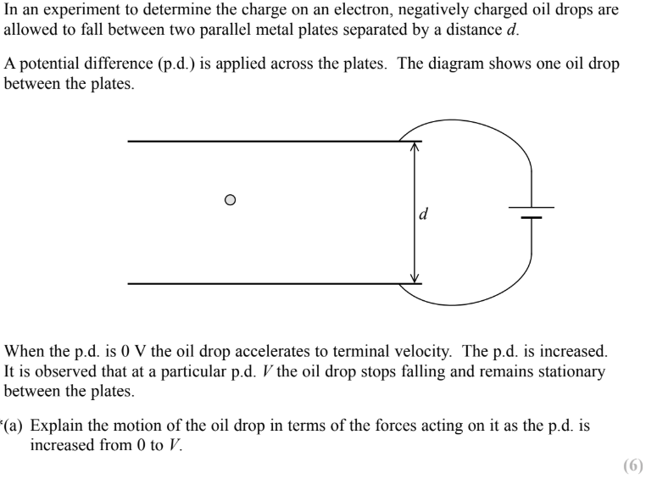 | 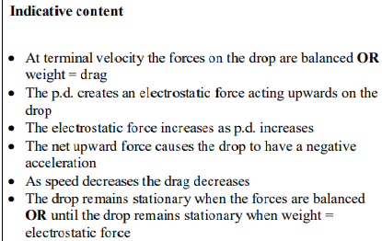

7.108 Understand that an electric field (force field) is defined as a region where a charged particle experiences a force
Define Electric Field? | A region of space in which a charged particle experiences a force
What are the 2 types of electric fields? | - Radial fields: 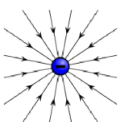  - Uniform fields:  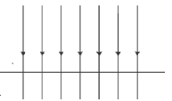  This is approximately what it looks like at the Earth’s surface

7.109 understand that electric field strength is defined as E=F/Q and be able to use this equation
Define Electric Field Strength and what are its 2 units and its equation? | - The force per unit positive charge (thus, its direction is the direction a positive charge would move)  - NC⁻¹ or Vm⁻¹  - E=F/Q  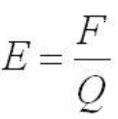  If the charge given is negative and thus the field strength too then the field points are going in the opposite direction

7.110 be able to use the equation $F=\frac{Q_{1}Q_{2}}{4πϵ_{0}r^{2}}$, for the force between two charges
What is permittivity? $ϵ_{0}$ | - How difficult it is to generate an electric field in a medium  - The higher the permittivity of a material, the more charge is needed to generate an electric field of a given size
What is Coulomb’s law and the quantities that are proportional to each other? | The force on a charged particle is directly proportional to the product of the two charges and inversely proportional to the distance of separation squared  (Force between two point charges where attractive is negative and repulsive is positive).  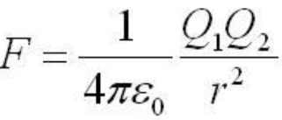  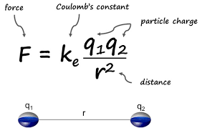  Air can be treated as a vacuum thus use ε₀

7.111 be able to use the equation $F=\frac{Q}{4πϵ_{0}r^{2}}$ for the electric field due to a point charge
What are the 3 Coulomb’s law equation variants for an electric field due to a point charge? | 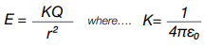  Then E=F/Q  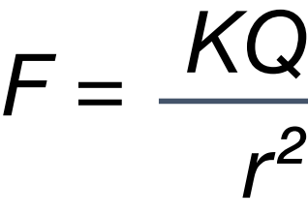  Tip:  If the charge is negative, the E field strength is negative and points towards the centre of the charge  If the charge is positive, the E field strength is positive and points away from the centre of the charge
What is the graph of E against radius (and F against r) for an electric field due to a point charge and its features? | 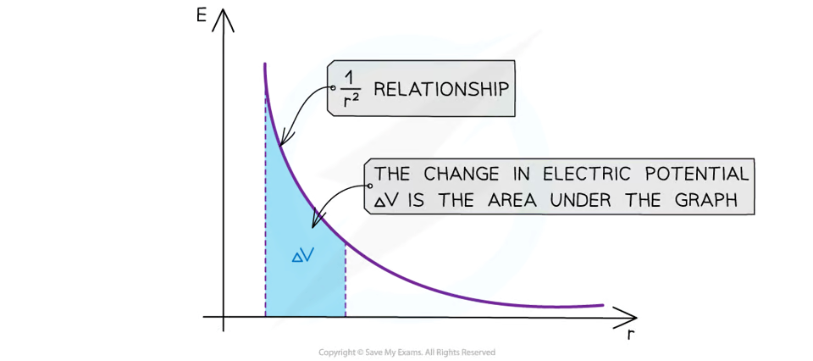  - The values for E are all positive  - As r increases, E against r follows a 1/r² relation due to the inverse squared law  - The area under this graph is the change in electric potential ΔV  - The graph has a steep decline as r increases

7.112 know and understand the relation between electric field and electric potential
Derive the distance of closest approach formula? | E_{P} = Q₁V (this is the electrical energy of the alpha particle when it is stationary where Q is the charge on the alpha particle) and is equal to the kinetic energy of the alpha particle.  $V=\frac{KQ_{2}}{r}$ (this is the electrical potential at the distance of closest approach, r, where Q₂ is the charge on the nucleus)  Therefore $EP=\frac{{KQ}_{1}Q_{2}}{r}=KE$ as well as  W = $\frac{{KQ}_{1}Q_{2}}{r}$  To which $r=\frac{kQ_{1}Q_{2}}{E_{k}}$  EP is also Workdone (W)  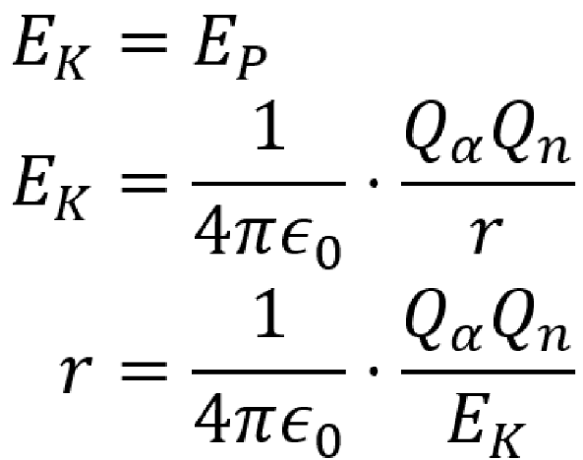  W is the work done needed to remove a particle from 2 point charges. The KE of an electron relies of v being << c in Ek =1/2mv²  Mr Adams: The equation is not given in formula booklet but is a good one to know
Draw the electric potential graph of potential V against distance (r) for a POSITIVE charge | 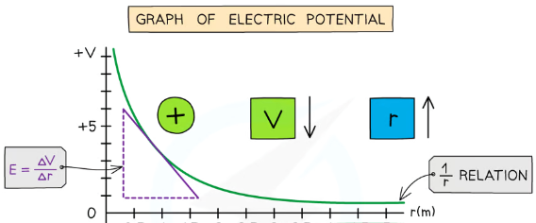
Draw the electric potential graph of potential V against distance (r) for a NEGATIVE charge | 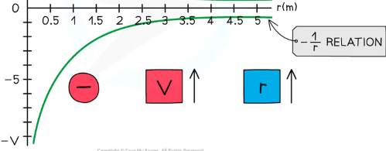

7.113 be able to use the equation E=V/d for an electric field between parallel plates
How does the electric field strength vary in a uniform field (with parallel plates) and what is its equation? | It is constant throughout the field ( E = Vm⁻¹ )  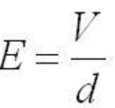  Where V is the potential difference between the plates and d is their separation

7.114 be able to user $V=\frac{Q}{4πϵ_{0}r}$for a radial field
What is Electric Potential and its equation? | The work required to move a unit charge from infinity to a point against the electric field.  V=KQ/r  Its change is given by the area under a graph of electric field strength against radius.  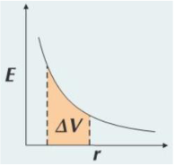

7.115 be able to draw and interpret diagrams using field lines and equipotentials to describe radial and uniform electric fields
Draw an electric field + equipotential line for a point positive and negative charge? | 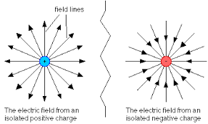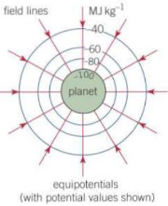
Draw an electric field + equipotential lines for two-like Point charges and between two-opposite Point charges? | 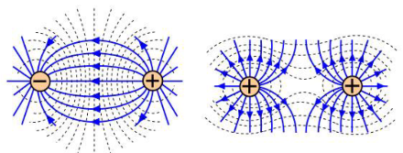
What is an equipotential?  How are they positioned for radial fields? | - They’re points at which gravitational potential or electric potential is constant ( you can travel along one with it changing).  - Equipotential are spaced further apart equally as the field strength decreases so you can move further with the same work done
Draw a uniform Electric Field + Equipotential lines and How are the equipotentials different in a uniform field? | - A field produced by connecting two parallel plates to opposite poles of a battery  - They’re parallel and evenly spaced  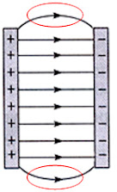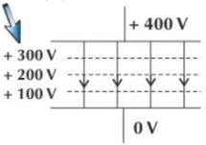  The electric field strength is constant throughout, the distance decreases so must the potential difference
Draw an electric field + equipotential lines for a point charge with a parallel plate | 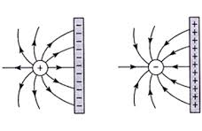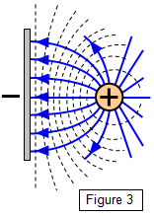

7.116 understand that capacitance is defined as C=Q/V and be able to use this equation
What is Capacitance defined as and its equation? | The charge transferred per unit voltage and C=Q/V
What is a Farad defined as? | The capacitance where 1 coulomb of charge is transferred per volt of PD
How does a capacitor become charged? | - Electrons move from the cell to the capacitor -> making one side negatively charged  - This side repels electrons on the other side making that positive.  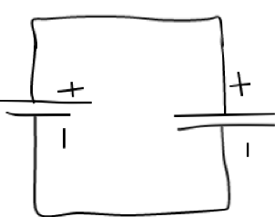
How can you maintain a constant current in a circuit with a capacitor? | 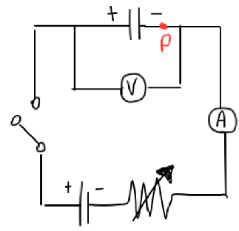  - Without a variable resistor, the current would increase over time as when enough negative charge builds up at P, it will repel incoming.  - With a variable resistor, you can have a high resistance at the start -> low current. Yet, when current begins you lower, you decrease resistor to bring it back up
What is the equation for capacitors for when there is 2 in series and in parallel | 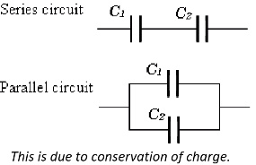  For series:  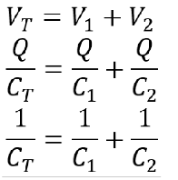  For parallel:  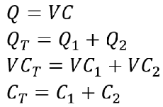  You don’t need to know derivation for both just the final equations

7.117 be able to use the equation W= 0.5QV for the energy stored by a capacitor, be able to derive the equation from the area under a graph of potential difference against charge stored and be able to derive and use the equations W=0.5CV² and $W=\frac{\frac{1}{2}Q^{2}}{C}$
Derive the 3 equations for the energy stored in a capacitor? From using a V against Q graph | 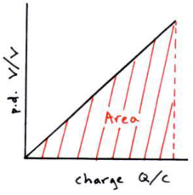  - W=$\frac{1}{2}QV$  - $V=\frac{Q}{C}$  - W = $\frac{Q}{2} × \frac{Q}{C}$  - W = $\frac{Q^{2}}{2C}$  - Q = CV  - $W = \frac{1}{2}(CV) × V$  - $W = \frac{1}{2}CV^{2}$  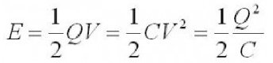  Half the energy is ‘lost’ under resistance. There is no way around this.  It the same derivation for a Charge against Voltage graph too.

7.118 be able to draw and interpret charge and discharge curves for resistor capacitor circuits and understand the significance of the time constant = RC
What is the charging graph of a capacitor with its equation and label how to find time constant ? | 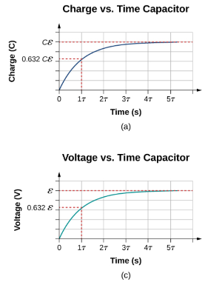  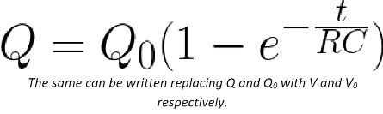  T= V₀/63%  As Q/C=V  V = V₀ (1 - e^{-t/RC})  As I=V/R  I = I₀ (1 - e^{-t/RC})  It tapers off to the emf of the battery because the rate at which charge comes in decreases. (The shape is the same as V = QC where C is a constant).  It’s considered fully charged after 5 time constants in this case
What is the discharging graph of a capacitor with its equation and label how to find time constant ? | 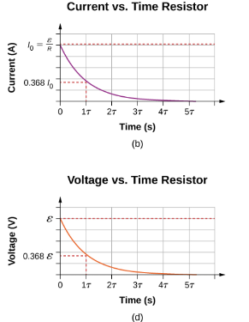  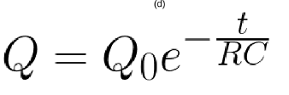  T= V₀/37%  As Q/C=V  V = V₀ e^{-t/RC}  As I=V/R  I = I₀ e^{-t/RC}  It’s considered fully discharged after 5 time constants in this case
What is the time constant equation of a capacitor | 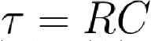  - Where R is the resistance and C is the capacitance of the circuit.  - Increasing T increases the time taken to charge and discharge so current flows for a longer time.
How does the (dis-) charging current circuit graph compare with the (dis-) charging charge capacitor graph? Why? | 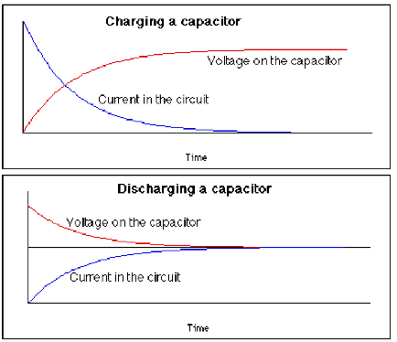  - The charging-current is the derivative of the charging-charge or proportional to charging-voltage

7.119 CORE PRACTICAL 11: Use an oscilloscope or data logger to display and analyse the potential difference (p.d.) across a capacitor as it charges and discharges through a resistor.

7.120 be able to use the equation Q = Q₀e^{-t/RC} and derive and use related equations for exponential discharge in a resistor-capacitor circuit, I = I₀ e^{-t/RC}, and V = V₀ e^{-t/RC} and the corresponding log equations lnQ = lnQ₀ - $\frac{t}{RC}$, ln I = lnI₀ - $\frac{t}{RC}$ and ln V = lnV₀ - $\frac{t}{RC}$
Derive lnQ = lnQ₀ − t/RC from Q=Q₀e^{-t/RC} | - Q=Q₀e^{-t/RC}  - lnQ = ln(Q₀e^{-t/RC})  - lnQ = lnQ0 + ln(e^{-t/RC})  - lnQ = lnQ₀ - t/RC

MAGNETIC FIELDS

7.121 understand and use the terms magnetic flux density B (also referred to as magnetic field strength), flux φ (magnetic flux) and flux linkage Nφ
Definition of a magnetic field? | A region of space where a magnetic material experiences a magnetic force
Definition, units and equation of magnetic flux φ (lines of magnetic flux) ? | - The product of tesla (B) and cross sectional area (A)  - Measured in Weber/Wb  - φ=BA  - φ=BAsinΘ  Referred to as “magnetic field lines” at GCSE
When is the magnetic flux φ through some cross sectional area at a maximum or minimum? | 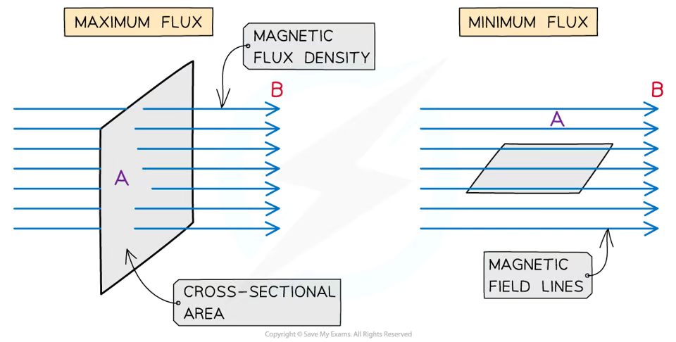  - Its at a maximum when perpendicular to the cross sectional area (as Θ = 90 degrees to the horizontal)  - Its at a minimum when parallel to the cross sectional area (as Θ = 0 degrees to the horizontal)
What does closer B field lines mean? | Greater flux density -> greater force on object here

7.122 be able to use the equation F = Bqv sinθ and apply Fleming’s left-hand rule to charged particles moving in a magnetic field
What is the equation for the force on a moving charge? | 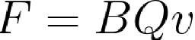  Where the particle is travelling perpendicular to the direction of the magnetic field and the B field is perpendicular to the velocity of the charge.
How does Fleming’s Left Hand Rule apply to a charge moving in a magnetic field? | The force is perpendicular to the direction of motion -> circular motion.  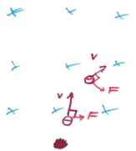  You have to be careful, current is conventional current - the direction in which a positive charge moves  And only one component of velocity will be affected (the component within the perpendicular plane).

7.123 be able to use the equation F = BIL sinθ and apply Fleming’s left-hand rule to current carrying conductors in a magnetic field
What is the magnetic flux density B equation and units? | - F=BILsinΘ  - Measure in Tesla (T) or Wbm⁻²  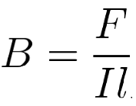  Defined as the force per unit length per unit current on a current carrying conductor at right angles to the magnetic field.
What is the right-hand grip rules and in what 2 cases it used? | Current-carrying conductor:  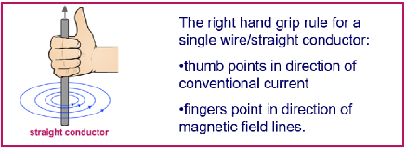  Solenoid:  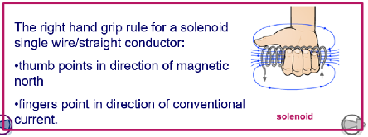
What is the motor effect? | The force exerted on a wire when a current passes along a wire in a magnetic field  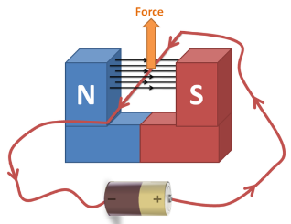
What does the force exerted in the motor effect depend on? | - The current in the wire and its direction  - Strength of the magnetic field  - Length of the wire  - Angle of the wire/current relative to the magnetic field lines.  The greatest force is experience when the wire is perpendicular to the field. No force is experienced when parallel
What is Fleming’s Left Hand rule? What is it used for? | 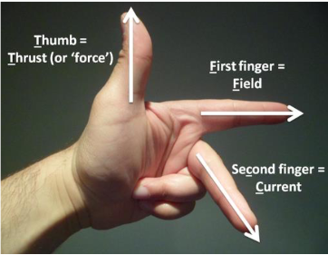  - Thumb = thrust/force  - First finger = field (going north to south)  - Second finger = conventional current  - Used to determine the direction of the force in the motor effect (where current and field are known).  Motor cars drive on left so we remember it as Fleming’s left hand rule for motor effect
What is Flemming’s Right hand rule? What is it used for? | 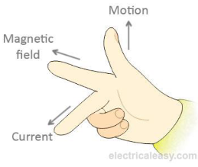  - Thumb = thrust / force  - First finger = field (going north to south)  - Second finger = conventional current  - Used for generators (geneRIGHTors).  - Used to determine the direction of current in the movement of the wire due to induction from Lenz’s law (where force and field are known)
Describe the context for where to use Flemming’s left and right hand rules? | - FLHR- This is where charge is moving (either as charged particles or a current in a wire) perpendicular to a B field and creates a force that is perpendicular to both the current and the B field (e.g. motor effect)  - FRHR- This is where a conductor is moving with a velocity perpendicular to the B field and therefore there is a change in the magnetic flux which would induce an EMF
How can the magnetic flux density be measured? | - Place magnet on balance  - Clamp wire in position so magnet can push down  - With no current passing through, set balance to zero  - We know mg = BIL
Explain the script to how a magnetic field acts a force on a current carrying conductor? | - The current in the wire produces a magnetic field around the wire  - This magnetic field interacts with the magnetic field from the permanent magnet  - Due to Flemming’s Left hand rule there is force acted upon the wire (either into/out of the plane or upwards/downwards)  - As the current and magnetic field are 90 degrees to each other  - The force is at 90 degrees to the magnetic field and current

7.124 understand the factors affecting the e.m.f. induced in a coil when there is relative motion between the coil and a permanent magnet
What are the 4 factors that affect induced EMF? | - The faster the object/motion (this reduces the time and increases the rate of change of flux)  - The higher the magnetic field strength (this increases the flux and hence increases the rate of change of flux)  - The higher the number of turns on the coil (this increases the flux linkage and rate of flux linkage)  - The more area of coil within the magnetic field (Increases the rate of change of flux)

7.125 understand the factors affecting the e.m.f. induced in a coil when there is a change of current in another coil linked with this coil

7.126 understand how to use Lenz’s law to predict the direction of an induced e.m.f. and how the prediction relates to energy conservation
What is Lenz’s Law? And its equation? | An induced EMF will cause a current to flow that create a magnetic field that will oppose the change in flux which caused it (this is a consequence of conservation of energy)    The explanation of this comes from the conservation of energy. Induced current can never be in a direction to help the change that cause it otherwise your producing electrical energy from nowhere
Explain the shape of the graph of EMF against time as a Magnet falls through a coil?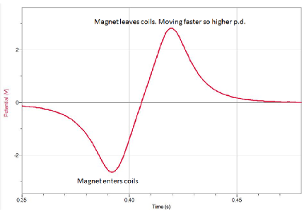  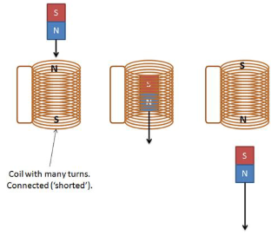 | - When the magnetic is at a distance there is small flux at the coil  - As the magnet gets closer to the coil the magnetic flux increases at the coil  - This causes a change in flux  - The change in flux causes an induced EMF due to Faraday’s law as there is a rate of change of flux  - At the point the magnet enters the coil there is a very large rate of change of flux therefore a large induced EMF  - As the magnet passes through the coil there is the largest flux at the coil but there is no change of flux and therefore no induced EMF  - As the magnet exits the coil the flux starts to decrease and therefore there is a large change in flux and a large negative EMF  - The induced EMF as the magnet leaves the coil is greater than when it entered the coil as the magnet has accelerated as it moved downwards and therefore increased the rate of change of flux and therefore increased the induced EMF
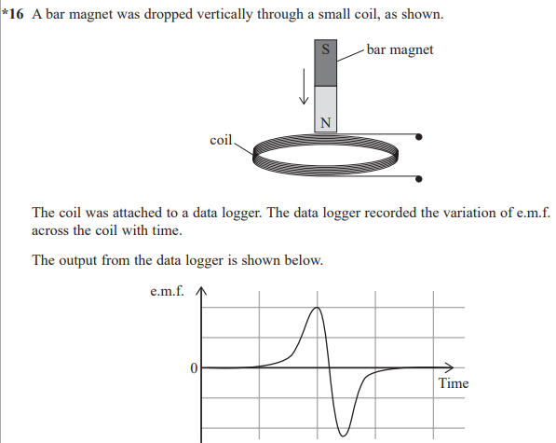 | 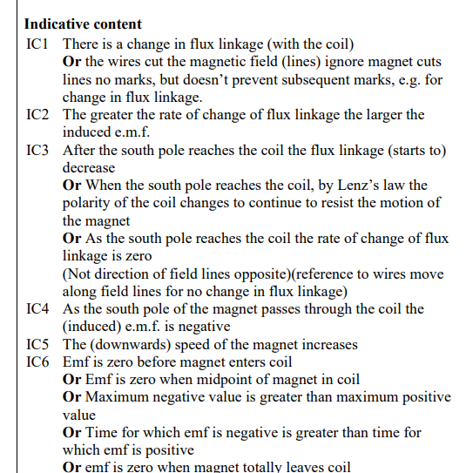

7.127 understand how to use Faraday’s law to determine the magnitude of an induced e.m.f. and be able to use the equation that combines Faraday’s and Lenz's laws $ε=\frac{-d(Nϕ)}{dt}$
What is Faraday’s Law? And its equation | The induced EMF is directly proportional to the rate of change of flux (linkage)  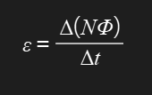
Describe the script for explaining how step up or step down transformers work? | - An alternating PD runs across the primary coil  - This causes an alternating current to flow in the primary coil  - This causes a alternating magnetic field in the soft iron core as it cuts through it  - The magnetic flux in the core links the primary and secondary coils  - As there is a change in flux in the secondary coil this induces a EMF across the secondary coil due to faraday’s law  - This causes an alternating current in the secondary coil if there is a complete circuit  - If the transformer is a step up then the number of turns on the secondary coil is greater than the primary and therefore the flux linkage is greater on the secondary than the primary and a greater EMF is induced across the secondary coil as there is greater rate of change of flux linkage  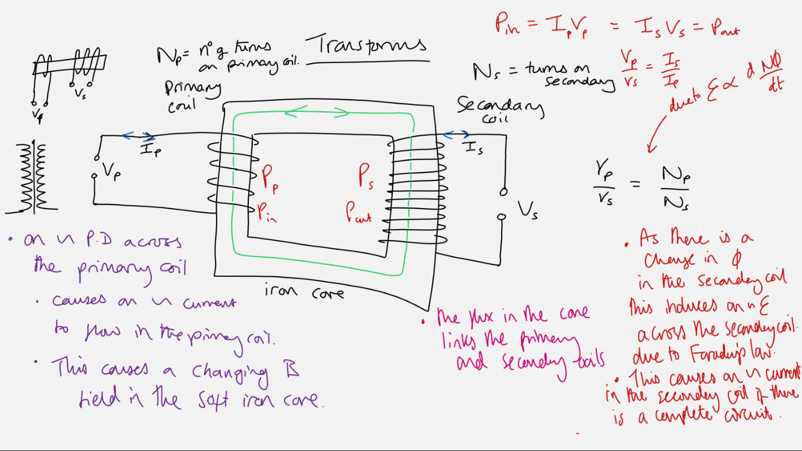
Why does a transformer not work if a DC current flows through it? | The rate of change of flux through the iron core is constant and so an EMF can not induced in the secondary coil

7.128 understand what is meant by the terms frequency, period, peak value and root-mean-square value when applied to alternating currents and potential differences

7.129 be able to use the equations $V_{rms}=\frac{V_{0}}{\sqrt{2}}$ and $I_{rms}= \frac{I_{0}}{\sqrt{2}}$
What is RMS Voltage? | 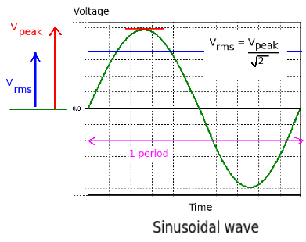  - This is the DC Equivalent of the AC voltage  - The sine wave in the UK is 50 Hz
What are the 2 equations for rms | - V_{rms} = V₀/root2  - I_{rms} = I₀/root2

